A SUMMER TRAINING PROJECT REPORT
ON
“SecureInfo Windows Software”
Submitted in partial fulfillment of
Master of Computer Application (MCA)



Session: 2022-2023
DEPARTMENT OF Computer Science &
INFORMATICS
UNIVERSITY OF KOTA, KOTA
Near Kabir Circle, MBS Marg,
Kota (Rajasthan)-324005, INDIA,
RAJASTHAN – INDIA

Submitted To: Submitted By:
PRATEEK KUMAWAT
SUPEPRVISOR:
DR. POONAM PAHUJA

CERTIFICATE

This is certified that summer training project entitled "SecureInfo windows Software" which is submitted by PRATEEK KUMAWAT of MCA 2nd Semester, Master of Computer Application, University of Kota, Kota for the award of the Post Graduation, is a Bonafide record of work carried out by them under guidance of DR. POONAM PAHUJA.

The content of this project has not been submitted to any university or institute for award of any degree or diploma.

PROJECT GUIDE: External Examiner
SUPEPRVISOR:
DR. POONAM PAHUJA

_ _ _ _ _ _ _ _ _ _ _ _ _ _ _ _ _ _ _ _ _ _ _

HEAD OF DEPARTMENT:
DR. PRAKASH CHANDRA GUPTA

_ _ _ _ _ _ _ _ _ _ _ _

Date: _ _/ _ _/ _ _ _ _

Place: Kota

ABSTRACT

"SecureInfo" is a Windows software designed to provide robust information security for various file types, including text, images, audio, video, and password-protected PDFs. The software leverages the power of ECC asymmetric encryption and decryption algorithms to ensure data confidentiality and integrity. Developed using Python programming language, the graphical user interface (GUI) is implemented with the tkinter library or PyCharm IDE.

The software offers users a comprehensive set of features to protect sensitive information. Upon registration, each user is assigned a unique set of ECC keys, which are generated only once and securely stored in a CSV database along with user information. These keys form the foundation of the encryption and decryption operations performed by the software.

SecureInfo's functionality encompasses a range of operations to safeguard data. Users can encrypt and decrypt text files, hiding text within images for added security. Furthermore, the software provides the ability to password-protect PDF documents, ensuring that only authorized individuals can access the contents.

The software's user-friendly interface allows for seamless navigation and interaction. Users can easily register and log in to the software, granting them access to the full suite of security features. All operations are executed with speed and efficiency, providing a streamlined experience for users.

By employing ECC asymmetric encryption, SecureInfo guarantees a high level of security for sensitive information. This cryptographic approach ensures that data remains confidential and tamper-proof, protecting against unauthorized access and potential data breaches.

The project showcases the potential of Python as a powerful programming language for developing robust software applications. The integration of the tkinter library or PyCharm IDE enables the creation of an intuitive GUI, facilitating user interaction and enhancing the overall user experience.

Key features of SecureInfo include secure file storage, file encryption and decryption using ECC, file compression to reduce storage requirements, and password-based access control. These features collectively provide users with a comprehensive solution to protect their information from unauthorized access.

ACKNOLEDGEMENT

Sometimes it is hard to find the proper word to express my gratitude, and that is how I sense proper now. I am notably grateful for the huge help and support I received from my faculty and guide, DR. POONAM PAHUJA. Their guidance and encouragement motivated me throughout the preparation of this project.
I would really like to expand my heartfelt thanks to DR. PRAKASH CHANDRA GUPTA (Head of the Department of CSI), DR. O.P. RISHI, DR. REENA DADHICH, DR. K.K. SHARMA and all the faculty members who provided valuable insights and support. Their expertise and dedication in sharing knowledge enriched my learning experience.
Lastly, I want to express my big gratitude to my parents for her or his tireless support and blessings. Their constant encouragement has been a driving force throughout this project.
I am grateful for the contributions and help of these individuals, which performed a crucial position in the successful completion of this project.

PRATEEK KUMAWAT

TABLE OF CONTENT

S.NO. | NAME OF CONTENT | PAGE
1 | INTRODUCTION | 1
1.1 | Project Overview | 1
1.2 | Objectives | 2
1.3 | Scope | 2
1.4 | System Requirements Specification (SRS) | 3
1.5 | Data Flow Diagrams (DFD) | 5
2 | BACK GROUND AND RELATED W0RK | 7
2.1 | Information Security | 7
2.2 | Encryption and Decryption | 8
2.3 | ECC Asymmetric Encryption | 9
3 | SOFTWARE DEVELOPMENT | 10
3.1 | Programming Language and Tools | 10
3.2 | GUI Development with tkinter or PyCharm IDE | 10
3.3 | Database Management | 11
4 | SYSTEM ARCHITECTURE | 12
4.1 | User Registration and Login | 12
4.2 | ECC Key Generation and Storage | 13
4.3 | Encryption and Decryption Operations | 14
4.4 | Text Hiding in Images | 17
4.5 | PDF Password Protection | 17
5 | IMPLEMENTATION DETAILS | 19
5.1 | Software Architecture | 19
5.2 | ECC Encryption and Decryption Algorithms | 20
5.3 | Integration with Python and Libraries | 22
5.4 | Database Design and Management | 22
6 | USER GUIDE | 24
6.1 | Installation Instructions | 24
6.2 | User Registration and Login Process | 24
6.3 | Encrypting and Decrypting Files | 26
7 | TESTING AND EVALUATION | 28
7.1 | Test Scenarios and Test Cases | 28
7.2 | Performance Evaluation | 29
7.3 | Security Assessment | 30
8 | RESULTS AND DISCUSSION | 31
9 | CONCLUSION | 32
10 | REFERENCES | 33

TABLE OF FIGURES

S.NO. | NAME OF FIGURES | PAGE
1. | Home DFD Level 0 | 5
2. | Detailed DFD | 6
3. | Home page Screen | 12
4. | Registration page Screen | 12
5. | Login page Screen | 13
6. | Text encrypt or decrypt page Screen | 15
7. | Image encrypt or decrypt page Screen | 15
8. | Audio encrypt or decrypt page Screen | 16
9. | Video encrypt or decrypt page Screen | 16
10. | Text hide page Screen | 17
11. | PDF protected page Screen | 18
12. | Software Architecture | 19
13. | Encryption algorithms | 21
14. | Decryption algorithms | 21
15. | select file | 26
16. | Encrypting file | 26
17. | select Encrypte file | 27
18. | Save decrypted file | 27
19. | Waterfall Methodology | 28

- INTRODUCTION

1.1 Project Overview:
The "SecureInfo" Windows software aims to address the critical need for information security by providing a comprehensive solution for safeguarding various types of data, including text, images, audio, video, and PDF files. In today's digital age, where data breaches and unauthorized access are prevalent, this project focuses on leveraging encryption techniques to protect sensitive information from potential threats.

The primary objective of the project is to develop a user-friendly software application that utilizes ECC asymmetric encryption and decryption algorithms. By incorporating these advanced cryptographic methods, "SecureInfo" ensures the confidentiality and integrity of data, offering users a reliable means to secure their valuable information.

The scope of the project encompasses several key functionalities. Firstly, the software allows users to register and create unique accounts, enabling personalized access to its features. During the registration process, ECC keys are generated for each user, ensuring a strong foundation for data encryption and decryption operations. The project also includes the development of a graphical user interface (GUI) using the tkinter library or PyCharm IDE, providing an intuitive and user-friendly experience.

Furthermore, the software supports various operations for securing different file types. Users can encrypt and decrypt text files, ensuring that sensitive information remains unreadable to unauthorized individuals. Additionally, the project incorporates a unique feature that enables users to hide text within images, adding an extra layer of security to sensitive data. Moreover, "SecureInfo" offers the ability to password-protect PDF files, restricting access only to authorized users.

By addressing these key aspects, the "SecureInfo" project aims to provide individuals and organizations with a powerful tool to safeguard their information. With a focus on user-friendliness, robust encryption algorithms, and a versatile range of secure operations, the software seeks to empower users to protect their data from potential threats and maintain confidentiality in an increasingly digital world.

1.2 Objectives:

- Develop a Secure Information Management System: The primary goal is to create a Windows software application that serves as a secure information management system. The software will offer a range of features and functionalities to encrypt, decrypt, and protect various file types, ensuring the confidentiality and integrity of sensitive data.
- Implement ECC Asymmetric Encryption: One of the main objectives is to incorporate ECC (Elliptic Curve Cryptography) asymmetric encryption and decryption algorithms into the software. By utilizing ECC, the project aims to provide a strong and efficient cryptographic solution that can withstand modern security threats.
- Create a User-Friendly Interface: The project seeks to develop a graphical user interface (GUI) using the tkinter library or PyCharm IDE, focusing on simplicity and ease of use. The objective is to provide users, regardless of their technical expertise, with an intuitive platform for managing their sensitive information securely.
- Enable Secure Operations on Various File Types: The project aims to support encryption, decryption, and protection operations on multiple file formats, including text, images, audio, video, and PDF files. By allowing users to secure a wide range of file types, the objective is to offer comprehensive protection for different kinds of sensitive information.
- Ensure User Account Management and Security: The project objective includes implementing a user registration and login system. Each user will have a unique account associated with them, enabling personalized access and secure storage of ECC keys. The objective is to establish a robust user management system that ensures secure authentication and authorized access to the software's features and functionalities.

1.3 Scope:

The scope of the "SecureInfo" project encompasses the development of a Windows software application with a focus on information security using ECC asymmetric encryption and decryption algorithms. The project's scope includes the following key aspects:

      - Encryption and Decryption Functionality: The software will provide users with the ability to encrypt and decrypt various file types, including text, images, audio, video, and PDF files. The scope covers the implementation of ECC asymmetric encryption algorithms to ensure the confidentiality of sensitive data. Users will be able to perform encryption and decryption operations seamlessly within the software.

      - Text Hiding in Images: The project includes a unique feature that enables users to hide text within images. This functionality adds an additional layer of security to sensitive information. The scope covers the development of algorithms and techniques to embed and extract hidden text from images, providing users with a covert method of storing and transmitting confidential data.

      - PDF Password Protection: The software will support the password protection of PDF files. Users will have the capability to apply password-based access restrictions to their PDF documents, ensuring that only authorized individuals can access the content. The scope includes the implementation of password-based encryption and decryption mechanisms for PDF files.

      - User Registration and Login: The project encompasses the development of a user registration and login system. Users will be able to create accounts within the software, providing them with personalized access to the encryption and decryption functionalities. The scope covers the generation of unique ECC keys for each user during the registration process and their secure storage in a CSV database.

- Graphical User Interface (GUI): The scope includes the development of a user-friendly GUI using either the tkinter library or the PyCharm IDE. The GUI will provide an intuitive interface for users to interact with the software and access its various features. The scope covers the design and implementation of GUI elements, navigation menus, and user input/output functionalities.

1.4 System Requirements Specification (SRS):
The System Requirements Specification (SRS) outlines the specific requirements for the "SecureInfo" software. Here are the key points regarding the SRS:
1. Data Requirements:
- The software is designed to securely handle various types of data, including text, images, audio, video, and PDF files.
- It should provide encryption and decryption capabilities to protect sensitive information.
- The software should support text hiding within images and PDF password protection.
- User registration and login information, along with the associated ECC keys, are stored securely in a CSV database. This database is integrated with cloud storage services, such as Google Drive, for data persistence and accessibility.
2. Functional Requirements:
- User Registration and Login: The software should allow users to register and login securely.
- ECC Key Generation: The software should generate ECC (Elliptic Curve Cryptography) key pairs for each registered user. Encryption and Decryption: The software should provide functionalities to encrypt and decrypt various types of data using ECC asymmetric encryption.
- Text Hiding in Images: The software should have the capability to hide text within images.
- PDF Password Protection: The software should enable password protection for PDF files.
3. Performance Requirement:
- The software should perform encryption and decryption operations efficiently to ensure a seamless user experience.
- It should handle data processing for various file types (text, images, audio, video, PDF) effectively and in a timely manner.
4. System Requirement:
- The software is developed using the Python programming language.
- The GUI is created using the tkinter library or PyCharm IDE.
- The software is compatible with Windows operating systems.
- Adequate storage space is required to store the software and user data.
5. Testing and Maintainability Requirement:
- The software should undergo thorough testing to ensure its functionality, security, and performance.
- It should be maintainable, allowing for future updates, bug fixes, and enhancements as needed.

The SRS provides a comprehensive overview of the system requirements for the "SecureInfo" software, including data handling, functionalities, performance, system specifications, and testing requirements. These requirements guide the development and ensure the software meets the desired objectives.

1.5 Data Flow Diagrams (DFD):
Data Flow Diagrams (DFD) are graphical representations that illustrate the flow of data within a system. They depict the processes, data sources, data stores, and the flow of data between them. In the context of the "SecureInfo" software, the DFD provides a visual representation of how data is processed and exchanged within the system.
The DFD for the "SecureInfo" software can be divided into several levels, starting from a high-level overview and gradually drilling down into more detailed diagrams. Here is a brief explanation of the DFD levels:
1. Context Level DFD:
- The context level DFD provides a broad view of the system, showing external entities interacting with the software. It represents the system as a single process and shows the flow of data between the system and external entities such as users, databases, and external systems.

2. Level 0 DFD:
- The level 0 DFD decomposes the system into major processes or functions. It illustrates the main processes involved in the "SecureInfo" software, such as user registration, login, encryption/decryption, text hiding in images, and PDF password protection. It also shows the major data stores involved, such as the user database and the encrypted files database.

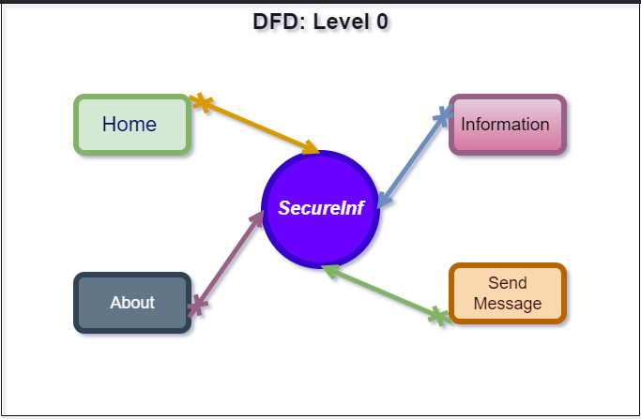
1: Home DFD Level 0

3. Detailed DFDs:
- Further levels of DFDs can be created to provide more detailed views of each major process identified in the level 0 DFD. These detailed DFDs break down the processes into sub-processes and show the data flow between them, including inputs, outputs, and data stores involved.

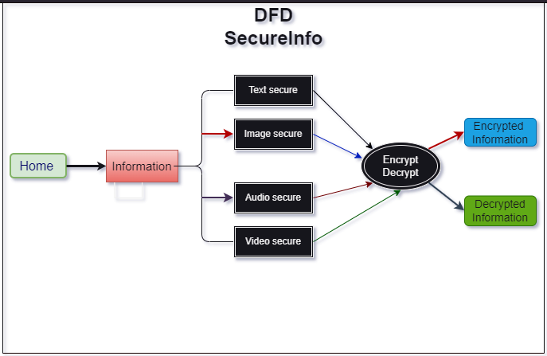
2: Detailed DFD

The DFDs aid in understanding the flow of data and the interactions between various components of the "SecureInfo" software. They provide a visual representation that helps in system analysis, design, and communication among stakeholders.

- BACKGROUND

2.1 Information Security:
Information security is a crucial aspect of the "SecureInfo" project. It involves protecting sensitive data from unauthorized access, disclosure, alteration, or destruction. The project recognizes the importance of maintaining the confidentiality, integrity, and availability of information, and aims to address these key aspects through robust security measures. The following points highlight the significance of information security within the project:

      - Confidentiality: Protecting the confidentiality of information is of paramount importance. The project utilizes ECC asymmetric encryption algorithms to ensure that sensitive data remains unreadable to unauthorized individuals. By encrypting the data, it becomes unintelligible without the corresponding decryption keys, thereby safeguarding its confidentiality.
      - Integrity: Information integrity refers to maintaining the accuracy, consistency, and trustworthiness of data. The project focuses on ensuring the integrity of stored information by implementing ECC asymmetric encryption and decryption. By employing cryptographic techniques, the software ensures that the data remains unaltered and tamper-proof. Any unauthorized modifications or alterations to the encrypted data will be detected during decryption, ensuring data integrity.
      - Access Control: Controlling access to information is vital for protecting sensitive data. The project incorporates user registration and login functionality, ensuring that only authorized individuals can access the software and its security features. By assigning unique ECC keys to each registered user, the project enables secure access to the encryption and decryption operations, enhancing access control and preventing unauthorized usage.
      - Data Breach Prevention: The project's focus on information security aims to prevent data breaches. By utilizing strong encryption algorithms and secure key management, the software mitigates the risk of unauthorized access to sensitive information. By protecting data at rest and in transit, the project aims to minimize the likelihood of data breaches and their associated consequences.
      - Compliance and Regulations: Information security is often governed by various compliance standards and regulations. The project considers the relevant legal and industry-specific requirements to ensure that the software adheres to applicable standards. By incorporating secure encryption practices and user authentication mechanisms, the software aims to align with industry best practices and legal obligations.

2.2 Encryption and Decryption:
Encryption and decryption are fundamental processes in information security that involve transforming data into a form that is unintelligible to unauthorized individuals and then restoring it to its original readable format, respectively. The "SecureInfo" project incorporates encryption and decryption functionalities using ECC asymmetric encryption algorithms. The following points provide an overview of encryption and decryption, different types, and an explanation of asymmetric encryption and decryption:
- Encryption: Encryption is the process of converting plaintext data into ciphertext using an encryption algorithm and a cryptographic key. The ciphertext is a scrambled, unreadable form of the original data. Encryption ensures the confidentiality of information by making it difficult for unauthorized parties to interpret the encrypted data. The two main types of encryption are symmetric encryption and asymmetric encryption.
- Symmetric Encryption: Symmetric encryption uses a single key, known as the secret key or shared key, for both encryption and decryption. The same key is used to both scramble and unscramble the data. It is a fast and efficient encryption method but requires securely sharing the key between the communicating parties.
- Asymmetric Encryption: Asymmetric encryption, also known as public-key encryption, uses a pair of mathematically related keys, namely the public key and the private key. The public key is used for encryption, while the private key is used for decryption. The public key can be openly shared, allowing anyone to encrypt data, while only the private key holder can decrypt it. Asymmetric encryption provides a higher level of security and eliminates the need for secure key exchange.
- Decryption: Decryption is the reverse process of encryption. It involves using the corresponding decryption algorithm and the appropriate key to transform the ciphertext back into its original plaintext form. The decryption process ensures the integrity and readability of the data for authorized individuals. In symmetric encryption, the same secret key used for encryption is employed for decryption. In asymmetric encryption, the private key, which is kept secret by the key owner, is used for decryption.
- Asymmetric Encryption and Decryption: Asymmetric encryption, also known as public-key encryption, offers distinct advantages over symmetric encryption. It addresses the challenge of securely sharing the secret key by employing a pair of mathematically related keys. In the "SecureInfo" project, ECC (Elliptic Curve Cryptography) is used for asymmetric encryption and decryption.
- Asymmetric Encryption with ECC: ECC is a modern public-key encryption algorithm that utilizes the mathematics of elliptic curves to provide strong encryption with shorter key lengths compared to other algorithms. In ECC, each user is assigned a unique key pair consisting of a private key and a corresponding public key. The public key is used to encrypt the data, while the private key is used for decryption. The mathematical properties of elliptic curves make ECC a highly efficient and secure encryption method.

- Asymmetric Decryption with ECC: The decryption process in ECC involves using the private key, which corresponds to the public key used for encryption. The private key is securely stored and kept confidential by the key owner. Only the holder of the private key can decrypt the data encrypted with the corresponding public key, ensuring the confidentiality and integrity of the information.

2.3 ECC Asymmetric Encryption:
ECC (Elliptic Curve Cryptography) is a widely used asymmetric encryption algorithm in the field of information security. It offers strong encryption capabilities with shorter key lengths compared to other encryption algorithms, making it efficient and suitable for resource-constrained environments. The "SecureInfo" project incorporates ECC asymmetric encryption to provide secure data protection. The following paragraphs explain ECC asymmetric encryption in more detail:
  - Key Generation: ECC utilizes mathematical properties of elliptic curves to generate a pair of related keys, namely the private key and the public key. The private key is kept secret by the key owner, while the corresponding public key is freely shared with others. The key generation process involves selecting a random private key and calculating the corresponding public key using the elliptic curve parameters. The generated key pair ensures the security and integrity of the encryption process.

- Encryption Process: In ECC asymmetric encryption, the sender uses the recipient's public key to encrypt the data. The encryption process involves converting the plaintext message into points on the elliptic curve and performing mathematical operations to derive the ciphertext. The resulting ciphertext is transmitted to the recipient, who possesses the corresponding private key needed for decryption. As ECC provides strong encryption, the ciphertext is computationally infeasible to decrypt without the private key.

- Decryption Process: The recipient of the encrypted message uses their private key to perform the decryption process. By applying mathematical operations using the private key and the ciphertext, the recipient retrieves the original plaintext message. ECC ensures that only the holder of the private key can decrypt the ciphertext, providing secure communication and data protection. The computational complexity of ECC makes it difficult for unauthorized individuals to obtain the private key and decrypt the encrypted data.

- SOFTWARE DEVELOPMENT

3.1 Programming Language and Tools:
The "SecureInfo" project utilizes specific programming languages and tools to develop the software application. The choice of programming language and tools is crucial in ensuring efficient development and the desired functionality. The following points highlight the programming language and tools used in the project:
- Python: Python programming language is chosen as the primary language for developing the "SecureInfo" software. Python is known for its simplicity, readability, and extensive libraries, making it suitable for rapid application development. Its versatility and robustness make it an ideal choice for implementing the encryption and decryption functionalities of the software.
- GUI Development: The project employs the tkinter library or the PyCharm IDE for GUI (Graphical User Interface) development. Tkinter is a popular Python library that provides a set of tools for creating user interfaces. It offers various widgets, such as buttons, input fields, and menus, to design an intuitive and interactive interface. Alternatively, PyCharm, a powerful integrated development environment for Python, can be used for GUI development, providing additional features for streamlined software development.
- ECC Libraries: As the project incorporates ECC asymmetric encryption, specific libraries or modules for ECC implementation are utilized. Python offers various libraries, such as cryptography and pyecc, that provide ECC functionalities. These libraries include functions for ECC key generation, encryption, and decryption, simplifying the implementation of ECC within the software. The selection of the appropriate library depends on factors such as performance, compatibility, and documentation.
- CSV Database: To store user information and ECC keys, a CSV (Comma-Separated Values) database is employed in the "SecureInfo" project. CSV databases are simple and widely supported, making them suitable for storing structured data. Python provides built-in modules for reading and writing CSV files, facilitating the integration of the database functionality into the software. The CSV database ensures efficient and organized storage of user data and associated ECC keys.

3.2 GUI Development with tkinter or PyCharm IDE:
The development of the graphical user interface (GUI) is a crucial aspect of the "SecureInfo" project, as it provides users with an intuitive and interactive interface to access the software's functionalities. The project utilizes either the tkinter library or the PyCharm IDE for GUI development. The following points outline the benefits and features of GUI development with tkinter or PyCharm IDE:

- Tkinter Library:
- Simplified GUI Development: tkinter is a built-in Python library that provides a set of tools and widgets for GUI development. It simplifies the process of creating graphical interfaces by offering a range of pre-built components, such as buttons, labels, input fields, and menus. These widgets can be easily customized and arranged to create a visually appealing and user-friendly interface.
- Cross-Platform Compatibility: tkinter is a cross-platform library, meaning that GUI applications developed using tkinter can run on various operating systems, including Windows, macOS, and Linux. This ensures that the "SecureInfo" software can be deployed and accessed by users regardless of their preferred operating system.
- PyCharm IDE:
- Enhanced Development Environment: PyCharm is a powerful integrated development environment (IDE) specifically designed for Python development. It offers a wide range of features, such as code highlighting, auto-completion, debugging tools, and version control integration. These features enhance the development process, making it more efficient and productive.
- Visual GUI Designer: PyCharm IDE includes a visual GUI designer tool that simplifies the creation of graphical interfaces. The visual designer provides a drag-and-drop interface for placing widgets and arranging them on the screen. This visual approach saves time and effort in GUI layout design and allows for real-time previewing of the interface.

3.3 Database Management:
Database management is a critical aspect of the "SecureInfo" project, as it involves storing, accessing, and managing user information and associated data. The following points explain the database management approach employed in the project, specifically regarding the use of cloud storage for storing the database and the software's ability to access, modify, and update data:
- Cloud as a Storage Solution: The project utilizes Google Drive as the storage solution for the database. Google Drive provides a cloud-based platform for storing files and data securely. By utilizing Google Drive, the "SecureInfo" software ensures that the database is accessible from anywhere with an internet connection, allowing users to access their information conveniently.
- Access, Modification, and Updating of Data: The "SecureInfo" software incorporates features that enable users to access, modify, and update their data stored in the database on Google Drive. The software provides functionalities to modify and update the data as required, ensuring that users have control over their stored information and can make necessary changes when needed.
By utilizing Google Drive as the storage solution, the "SecureInfo" project ensures secure and convenient database management. The software enables users to access, modify, and update their data stored in the database, providing a user-friendly experience and empowering users to have control over their information. The use of cloud storage enhances the accessibility and availability of the database, making it easily accessible from any device with an internet connection.
- SYSTEM ARCHITECTURE
4.1 User Registration and Login:
User registration and login functionality is a crucial component of the "SecureInfo" project, as it enables users to create an account, provide their information, and securely access the software. The following points explain the user registration and login process, focusing on the registration page and login page, along with the associated data storage and authentication:
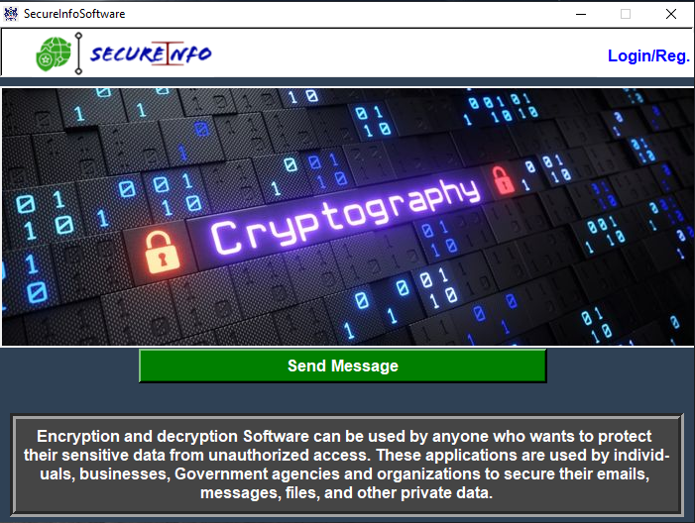
3: Home page Screen
- Registration Page:
- Information Collection: The registration page serves as a form where users can enter their details, such as username, full name, mobile number, password, and confirmation password. The page ensures that all required information is collected from the user accurately and securely.
- Data Storage: Once the user submits the registration form, the provided information is securely saved in the database. The data, including the username, full name, mobile number, and password, is stored in the appropriate fields of the database for future reference and authentication.
- Validation and Security Measures: The registration page incorporates validation checks to ensure that the entered information meets the required criteria. This includes verifying the uniqueness of the username and enforcing password complexity rules. Additionally, security measures, such as encrypting the password before storing it in the database, are implemented to safeguard user credentials.
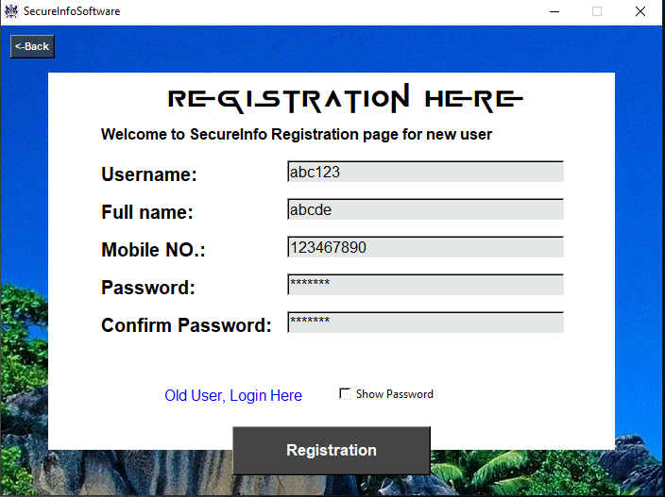
4: Registration page Screen
- Login Page:
- Authentication Process: The login page allows registered users to access the "SecureInfo" software by entering their username and password. Upon submission, the entered credentials are verified against the stored data in the database to authenticate the user.
- Access to Software: If the entered username and password match the stored data, the user is granted access to the software, enabling them to utilize its functionalities. Successful login ensures that the user can securely interact with their stored information and perform the desired operations within the software.
- Error Handling: The login page incorporates error handling mechanisms to provide appropriate feedback to users in case of incorrect credentials. Error messages or prompts are displayed to indicate login failures, helping users troubleshoot and rectify any mistakes.
By providing a comprehensive registration page and login page, the "SecureInfo" project facilitates user account creation, information storage, and secure access to the software. The registration page collects and securely stores user information in the database, allowing users to create their accounts. The login page enables registered users to authenticate themselves using their username and password, granting access to the software's functionalities. These features ensure that users can securely interact with their data and utilize the full capabilities of the "SecureInfo" software.
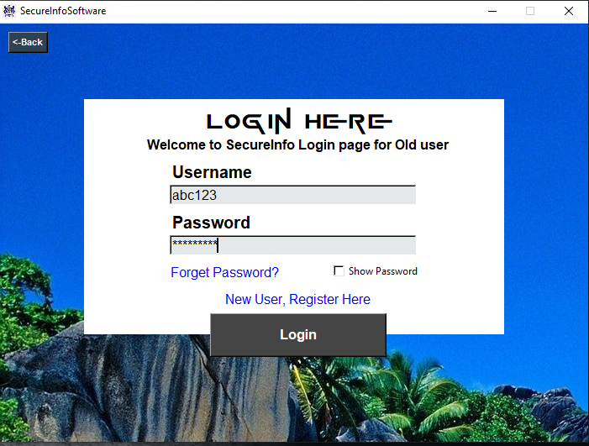
5: Login page Screen

4.2 ECC Key Generation and Storage:
ECC key generation and storage play a crucial role in the "SecureInfo" project, as they provide the necessary encryption and decryption capabilities for data security. The following points explain the process of ECC key generation and storage in the project:
- Key Generation:
- ECC Key Pair: The project utilizes ECC (Elliptic Curve Cryptography) to generate a pair of related keys - the private key and the public key. The key generation process involves selecting a random private key and calculating the corresponding public key using the parameters of the chosen elliptic curve. ECC ensures the generation of strong and unique key pairs for each user.
- One-Time Generation: ECC keys are generated for each user during the registration process. The key generation process occurs only once per user, ensuring that a unique key pair is associated with each registered user. This one-time generation enhances the security of the keys and simplifies the subsequent encryption and decryption processes.
- Key Storage:
- CSV Database: The generated ECC key pairs, along with the user's associated information, are securely stored in a CSV (Comma-Separated Values) database. The CSV database serves as a structured storage solution, enabling efficient retrieval and management of user data. The private keys are stored securely in the database, ensuring that they remain confidential and accessible only to the respective users.
- Security Measures: To ensure the confidentiality and integrity of the stored keys, appropriate security measures are implemented. This includes encrypting the private keys before storing them in the database. Encryption safeguards the keys from unauthorized access and ensures that only authorized users can decrypt and utilize their respective private keys. To maximize user understanding, the Home Page also showcases step-by-step solutions for conversions and arithmetic operations. This function allows users to visualize the intermediate steps concerned in the process, helping in understanding and studying.

4.3 Encryption and Decryption Operations:
The "SecureInfo" project incorporates various encryption and decryption operations to ensure the security and privacy of different types of data. The software provides functionalities for text encryption or decryption, image encryption or decryption, audio encryption or decryption, and video encryption or decryption. The following points explain these operations:
- Text Encryption and Decryption:
- Functionality: The software allows users to encrypt plain text messages or files using ECC encryption. The encryption process converts the text into an unreadable format, ensuring confidentiality. Users can also decrypt encrypted text to retrieve the original plain text using their private key.
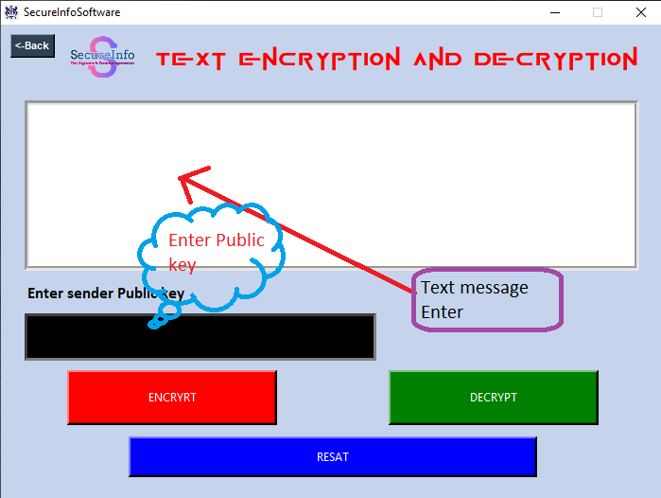
6: Text encrypt or decrypt page Screen

- Image Encryption and Decryption:
- Functionality: The "SecureInfo" software enables users to encrypt image files to protect their content. Encryption algorithms are applied to the image data, rendering it unreadable without the corresponding private key. Users can decrypt the encrypted image files to restore them to their original form using their private key.
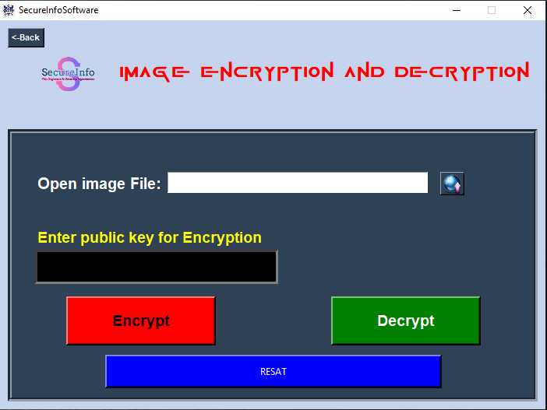
7: Image encrypt or decrypt page Screen

- Audio Encryption and Decryption:
- Functionality: The software offers the capability to encrypt audio files for secure storage and transmission. Encrypted audio files are generated by applying encryption algorithms to the audio data, making them inaccessible without the appropriate private key. Users can decrypt the encrypted audio files to recover the original audio content using their private key.
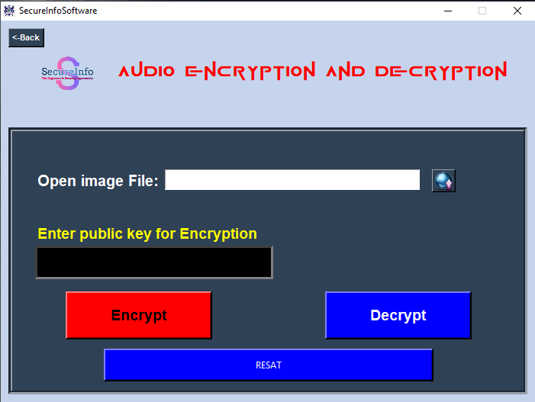
8: Audio encrypt or decrypt page Screen

- Video Encryption and Decryption:
- Functionality: The "SecureInfo" software supports the encryption of video files to protect their content from unauthorized access. Encryption algorithms are employed to transform the video data into an encrypted format, ensuring its confidentiality. Users can decrypt the encrypted video files using their private key to restore the original video content.
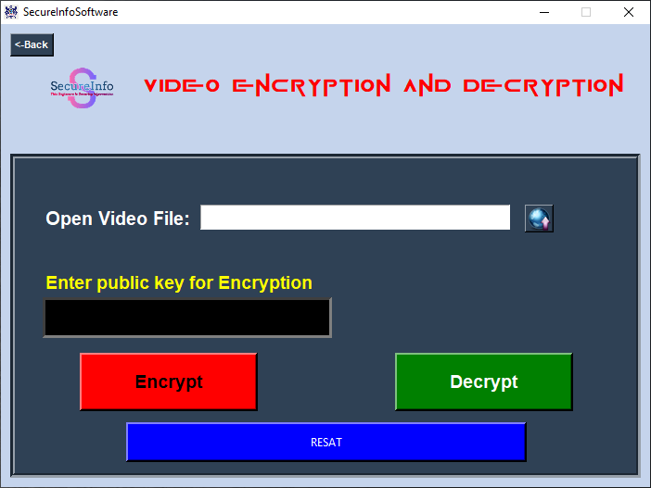
9: Video encrypt or decrypt page Screen

By incorporating these encryption and decryption operations, the "SecureInfo" software provides users with the means to secure various types of data. The text encryption and decryption functionality ensures the privacy of textual messages or files. Image, audio, and video encryption and decryption operations protect the content of multimedia files. Users can apply encryption to their desired data and decrypt it when needed, leveraging the security provided by ECC encryption algorithms and their associated private keys.
4.4 Text Hiding in Images:

The "SecureInfo" project incorporates a feature that allows users to hide text within images, enhancing data security and confidentiality. The following points explain the functionality and process of text hiding in images:
- Text Hiding Functionality:
- Purpose: The text hiding feature enables users to embed text messages or files within images discreetly. This technique provides an additional layer of security by concealing sensitive information within an image, making it less likely to be detected or intercepted.
- Concealed Data Retrieval: Users can later retrieve the concealed text from the image using the "SecureInfo" software. This allows for secure communication and storage of sensitive textual information, leveraging the camouflage provided by the image.
- Process of Text Hiding in Images:
- Input: Users provide the desired text message or file that they wish to hide within an image. This can include confidential notes, passwords, or any other sensitive information that requires protection.
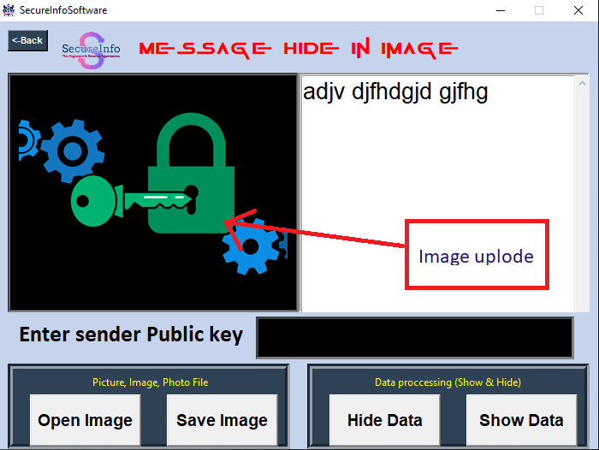
10: Text hide page Screen
- Image Selection: Users select an image file that will serve as the carrier for the hidden text. The chosen image should ideally have sufficient complexity and variation in colors or patterns to provide a higher degree of concealment.

4.5 PDF Password Protection:
The "SecureInfo" project includes a feature that enables users to apply password protection to PDF documents, ensuring their confidentiality and restricting unauthorized access. The following points explain the functionality and benefits of PDF password protection:

- Password Protection Functionality:
- Purpose: The PDF password protection feature allows users to encrypt their PDF documents with a password. This prevents unauthorized individuals from opening or viewing the contents of the PDF without the correct password.

- Access Control: By setting a password on a PDF document, users can control who can access the information within it. Only those who possess the correct password will be able to open the PDF and view its content, adding an additional layer of security.

- Process of PDF Password Protection:
- Password Assignment: Users select a password of their choice and assign it to the PDF document they want to protect. The password should be strong, unique, and not easily guessable to ensure maximum security.

- Encryption: The "SecureInfo" software utilizes encryption algorithms to encrypt the PDF document with the assigned password. Encryption transforms the contents of the PDF into an unreadable format, rendering it inaccessible without the correct password.
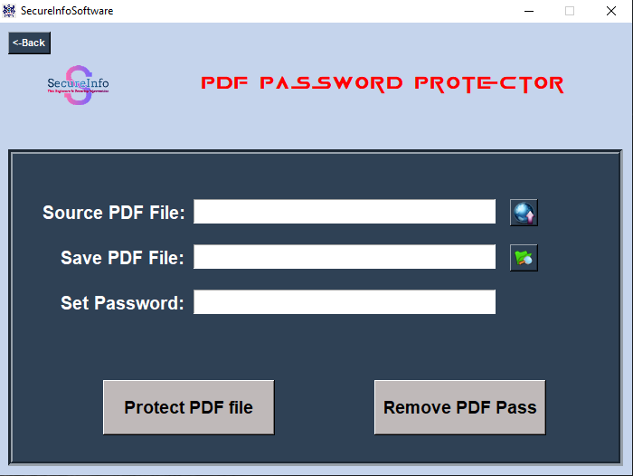
11: PDF protected page Screen

- IMPLEMENTATION DETAILS

5.1 Software Architecture:

The "SecureInfo" software is designed with a well-defined architecture that ensures efficient operation and maintainability. The following points explain the key aspects of the software architecture:
- Layered Architecture:
- Presentation Layer: The presentation layer handles the user interface and interaction. It is responsible for displaying the graphical user interface (GUI) elements using the tkinter library and capturing user input.

- Business Logic Layer: The business logic layer contains the core functionality of the software. It implements the encryption and decryption algorithms, text hiding in images, PDF password protection, and other data manipulation operations. This layer ensures the security and integrity of the data and handles the execution of different operations based on user requests.

- Data Access Layer: The data access layer is responsible for managing the connection and interaction with the CSV database where user information and ECC key pairs are stored. It handles the retrieval and storage of data from the database and ensures the integrity and security of the stored information.

- Modular Design:
- Modular design principles are employed to enhance code organization and maintainability. The software is divided into smaller, manageable modules or functions that perform specific tasks. This modular approach promotes code reusability, scalability, and ease of maintenance.

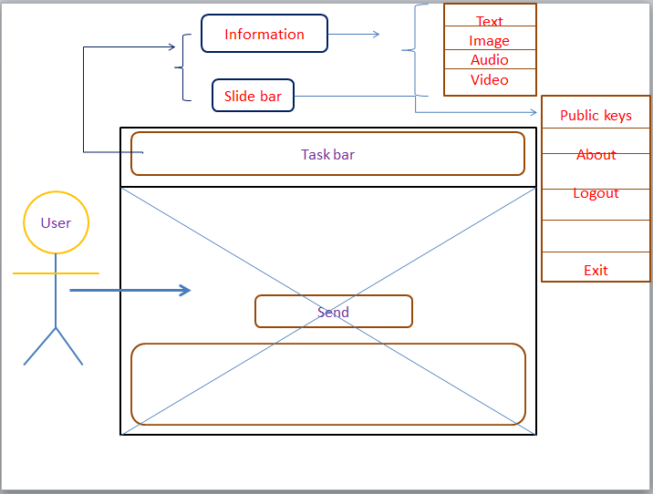
12: Software Architecture
- Secure Communication:
- To ensure secure communication between the different layers of the software, appropriate security measures are implemented. This includes encryption of sensitive data during transmission, secure handling of user credentials, and protection against common security vulnerabilities, such as SQL injection and cross-site scripting (XSS).

- Error Handling and Exception Management:
- The software incorporates robust error handling mechanisms to handle exceptional scenarios and provide meaningful error messages to users. Proper exception management techniques are implemented to catch and handle runtime errors, ensuring the stability and reliability of the software.

- Scalability and Extensibility:
- The software architecture is designed to be scalable and extensible, allowing for future enhancements and additional features. It provides a solid foundation to accommodate future requirements, such as incorporating new encryption algorithms, expanding supported file types, or integrating with other databases or cloud storage solutions.

5.2 ECC Encryption and Decryption Algorithms:

The "SecureInfo" software implements ECC (Elliptic Curve Cryptography) encryption and decryption algorithms for secure data protection. The provided code snippet demonstrates the usage of these algorithms using the cryptography library in Python. Here is an explanation of the code:

- Key Generation:
- The `generate_keys()` function generates a private key and a corresponding public key using the `ec.generate_private_key()` method. It uses the `ec.SECP256R1()` elliptic curve for key generation.

- Encryption:
- The `encrypt()` function takes the plain text to be encrypted, the private key, and the recipient's public key as inputs.
- The plain text is encoded into bytes using UTF-8 encoding.
- A shared key is derived by performing an Elliptic Curve Diffie-Hellman (ECDH) key exchange between the private key and the recipient's public key.
- The shared key is used to derive an encryption key using HKDF (HMAC-based Key Derivation Function) with SHA-256 as the hashing algorithm.
- An AES-GCM (Advanced Encryption Standard-Galois/Counter Mode) cipher is created using the derived encryption key.
- A nonce (a unique value) is generated.
- The plain text is encrypted using AES-GCM with the nonce and additional authenticated data (None in this case).
- The encrypted cipher text is returned as a hexadecimal string.
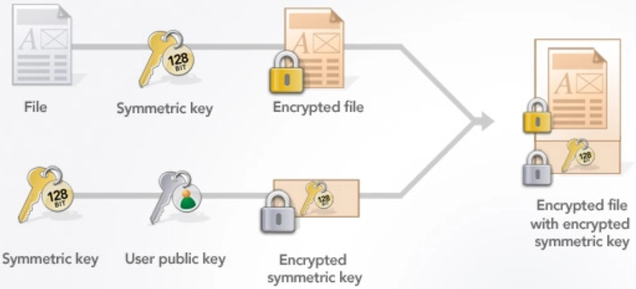
13: Encryption algorithms

- Decryption:
- The `decrypt()` function takes the cipher text to be decrypted, the private key, and the sender's public key as inputs.
- The cipher text is converted from a hexadecimal string to bytes.
- A shared key is derived by performing an ECDH key exchange between the private key and the sender's public key.
- The shared key is used to derive the same encryption key used during encryption.
- An AES-GCM cipher is created using the derived encryption key.
- The same nonce used during encryption is provided.
- The cipher text is decrypted using AES-GCM with the nonce and additional authenticated data.
- The decrypted plain text is returned as a UTF-8 encoded string.
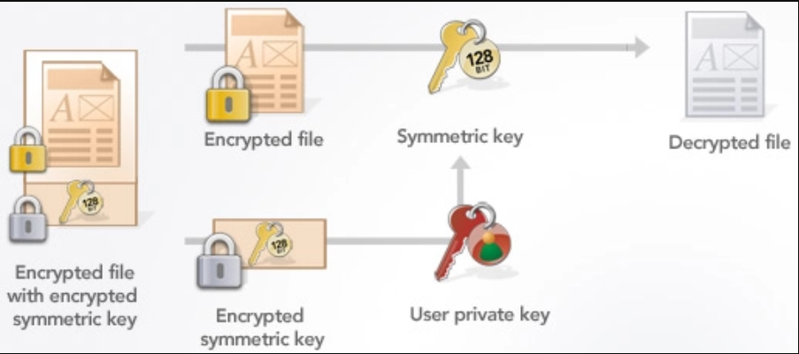
14: Decryption algorithms

- Example Usage:
- The code demonstrates an example usage of the ECC encryption and decryption functions.
- It generates a private key and a public key using the `generate_keys()` function.
- The private key is printed in PEM format without encryption, and the public key is printed in PEM format.
- A message, "Hello, ECC! I am a student," is encrypted using the `encrypt()` function with the private key and public key.
- The resulting cipher text is printed.
- The cipher text is decrypted using the `decrypt()` function with the private key and public key.
- The decrypted plain text, "Hello, ECC! I am a student," is printed.

5.3 Integration with Python and Libraries:

The "SecureInfo" software seamlessly integrates with Python and various libraries to provide robust functionality and enhance the user experience. The following points explain the integration and utilization of Python and libraries within the software:
- Python Language:
- The "SecureInfo" software is developed using the Python programming language. Python's simplicity, readability, and extensive library support make it an ideal choice for implementing the software's features and functionality.

- Cryptography Library:
- The cryptography library is utilized for implementing encryption and decryption operations within the "SecureInfo" software. This library provides a comprehensive set of cryptographic primitives, including elliptic curve cryptography (ECC), hashing algorithms, key derivation functions, and ciphers.

- Tkinter Library:
- The tkinter library is used for GUI development within the "SecureInfo" software. tkinter provides a set of widgets and functions for creating graphical user interfaces, allowing users to interact with the software intuitively. It offers features such as windows, buttons, text fields, and labels to design the user interface elements.

- PyCharm IDE:
- The PyCharm Integrated Development Environment (IDE) is mentioned as the preferred IDE for developing the "SecureInfo" software. PyCharm provides a powerful coding environment with features like code completion, debugging tools, version control integration, and project management. It facilitates efficient development and testing of the software.

- Integration Benefits:
- Python's integration with various libraries, such as cryptography and tkinter, enhances the functionality of the "SecureInfo" software. It enables seamless implementation of encryption, decryption, GUI development, and other critical operations related to information security.

5.4 Database Design and Management:

The "SecureInfo" software incorporates a robust database system for efficient storage and management of user information and ECC key pairs. The following points outline the key aspects of the database design and management within the software:
1. Database Selection and Design:
- The software utilizes a relational database management system (RDBMS) to store and manage user data. Popular RDBMS options in Python include MySQL, PostgreSQL, or SQLite, offering structured storage and efficient data retrieval.

2. Database Schema:
- The database schema is carefully designed to include tables that store relevant user information, such as username, full name, mobile number, passwords, and ECC key pairs. Each table corresponds to a specific entity or aspect of the software's functionality.

3. Data Storage and Retrieval:
- The database stores user information and ECC key pairs in a structured manner, allowing for efficient storage and retrieval of data. Queries and operations can be performed to fetch, insert, update, and delete records as needed.

4. Security Measures:
- To ensure data security, the software incorporates various security measures at the database level. This includes implementing strong password policies, encrypting sensitive information, and enforcing user authentication and authorization mechanisms to restrict access to authorized individuals.

5. Integration with Google Drive:
- The "SecureInfo" software integrates with the Google Drive API to provide seamless storage, modification, and access to the database. This integration enables users to securely store their data on Google Drive, leveraging its robust infrastructure and ensuring data availability.

6. Data Backup and Recovery:
- Regular backups of the database are performed to prevent data loss. These backups can be stored on Google Drive or any other suitable storage solution. In the event of system failures or data corruption, the backups can be utilized to restore the database to a previous state.

7. Data Validation and Integrity:
- The software incorporates data validation mechanisms to ensure the integrity and accuracy of user input before storing it in the database. This helps maintain data consistency and reliability, reducing the risk of storing invalid or incorrect data.

8. Scalability and Performance:
- The database design accounts for scalability to accommodate a growing number of users and data volume. By optimizing queries and database performance, the software ensures efficient data retrieval and management, even as the user base expands.

- USER GUIDE

6.1 Installation Instructions:

The following points provide instructions for installing the "SecureInfo" software on a Windows system:
1. System Requirements:
- Ensure that your system meets the minimum requirements for running the software. This typically includes a compatible version of the Windows operating system, sufficient RAM, and available storage space.

2. Download the Software:
- There are two options for downloading the "SecureInfo" software:
a. Creator's Drive Link: Visit the provided link to access the software's installation package on the creator's Google Drive. Click on the download link or button to initiate the download process.
b. GitHub Repository: Alternatively, you can download the software from the GitHub repository. Visit the repository's page, navigate to the "Releases" section, and download the latest release package as a ZIP or TAR file.

3. Extract the Installation Package:
- Once the download is complete, locate the downloaded installation package (usually a compressed file format like ZIP or TAR). Right-click on the file and choose the "Extract" option to extract the contents to a desired location on your system.

4. User Registration and Login:
- Upon launching the software, you will be presented with the registration and login pages. Fill in the required information for user registration, including username, full name, mobile number, password, and confirm password. After registering, use the provided credentials to log in to the software.

5. Start Exploring:
- Once logged in, you can begin exploring the various features and functionalities offered by the "SecureInfo" software. These may include text encryption and decryption, image, audio, and video encryption and decryption, PDF password protection, and text hiding within images.

6.2 User Registration and Login Process:

The "SecureInfo" software provides a user-friendly registration and login process to ensure secure access to its features. The following points outline the steps involved:

1. Launch the Software:
- Open the "SecureInfo" software on your Windows system by double-clicking the application icon or executing the software's launch command.

2. Registration and Login Options:
- Upon launching the software, you will be presented with the main interface, which typically displays options for registration and login. Click on the appropriate button to proceed.

3. User Registration:
- If you are a new user and wish to register, click on the "Registration" button. This action will redirect you to the registration page.

4. Fill in Registration Details:
- On the registration page, you will be prompted to provide your details, such as username, full name, mobile number, password, and confirm password. Fill in all the required information accurately.

5. Complete the Registration Process:
- After filling in the registration details, click on the "Register" or "Submit" button to complete the registration process. The software will validate the provided information, and if successful, your user account will be created.

6. Login to the Software:
- Once registered, return to the main interface and click on the "Login" button. This action will direct you to the login page.

7. Enter Login Credentials:
- On the login page, enter your username and password that you provided during the registration process. Ensure that the information is accurate and free of any typos.

8. Authenticate and Access the Software:
- After entering your login credentials, click on the "Login" or "Submit" button to authenticate your identity. If the provided username and password match the registered information, you will be granted access to the software's main features.

9. Explore the Software:
- Once logged in, you can explore the various functionalities of the "SecureInfo" software, including text encryption and decryption, image, audio, and video encryption and decryption, PDF password protection, and text hiding within images. Navigate through the software's user interface to access these features.

The user registration and login process ensures that only authorized users can access the "SecureInfo" software. By following the steps outlined above, you can successfully register as a user, log in with your credentials, and begin utilizing the software's secure information management capabilities.

6.3 Encrypting and Decrypting Files:

The "SecureInfo" software offers the functionality to encrypt and decrypt various types of files securely. The following points outline the process of encrypting and decrypting files within the software:
1. Select the File:
- Start by selecting the file you want to encrypt or decrypt. This can be a text file, image file, audio file, video file, or any other supported file format.
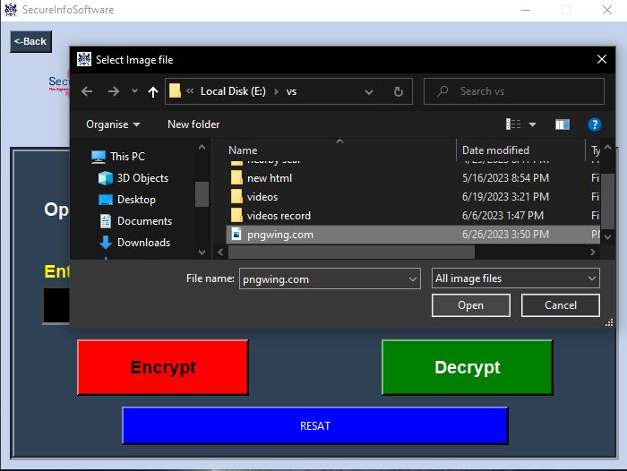
15: select file
2. Encryption:
- To encrypt the selected file, navigate to the encryption feature within the software. This can typically be accessed through a menu or toolbar option specifically designed for encryption operations.
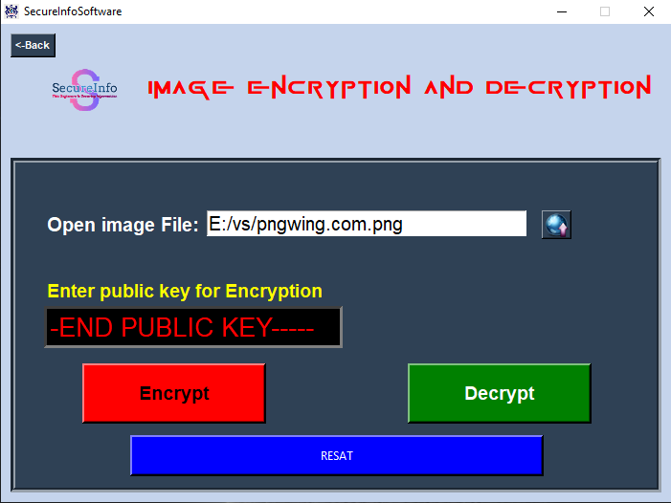
16: Encrypting file
3. Choose Encryption Algorithm:
- The software may provide multiple encryption algorithms to choose from. Select the desired algorithm based on your security requirements. For example, you may choose the ECC asymmetric encryption algorithm for its strong security properties.
4. Specify Encryption Parameters:
- Depending on the chosen encryption algorithm, you may need to specify additional parameters such as encryption keys, encryption strength, or encryption modes. Follow the software's instructions to provide the necessary parameters.
5. Encrypt the File:
- Once all the parameters are set, initiate the encryption process. The software will apply the encryption algorithm to the selected file, converting it into an encrypted format. This process ensures that the file's content is protected and can only be accessed with the corresponding decryption key.
6. Save the Encrypted File:
- After encryption, the software will prompt you to specify a location to save the encrypted file. Choose an appropriate destination and save the encrypted file securely.
7. Decryption:
- To decrypt an encrypted file, access the decryption feature within the software. This feature is typically separate from the encryption feature and can be found in the software's menu or toolbar.
8. Select the Encrypted File:
- In the decryption interface, select the encrypted file you wish to decrypt. Ensure that you have the necessary decryption key or credentials to access the file.
17: select Encrypte file
9. Choose Decryption Algorithm:
- Similar to encryption, the software may offer multiple decryption algorithms. Select the appropriate algorithm corresponding to the encryption algorithm used for encrypting the file.
10. Decrypt the File:
- Initiate the decryption process, providing the required decryption key or credentials. The software will apply the decryption algorithm to the encrypted file, restoring it to its original format and content.
11. Save the Decrypted File:
- After successful decryption, choose a destination to save the decrypted file. Ensure that you have appropriate permissions and security measures in place to protect the decrypted file.
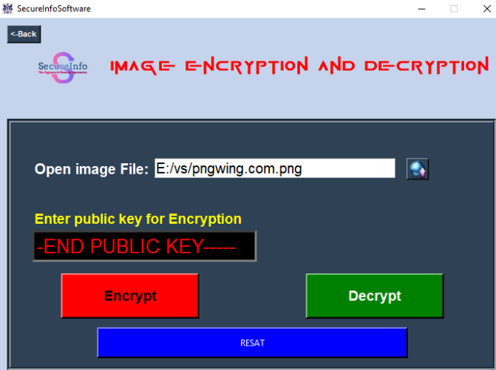
18: Save decrypted file
- TESTING AND EVALUATION

7.1 Test Scenarios and Test Cases:

Testing is an essential part of software development to ensure its functionality, reliability, and security. The "SecureInfo" software incorporates various test scenarios and test cases to validate its features and operations. The following points outline the test scenarios and test cases considered for the software:

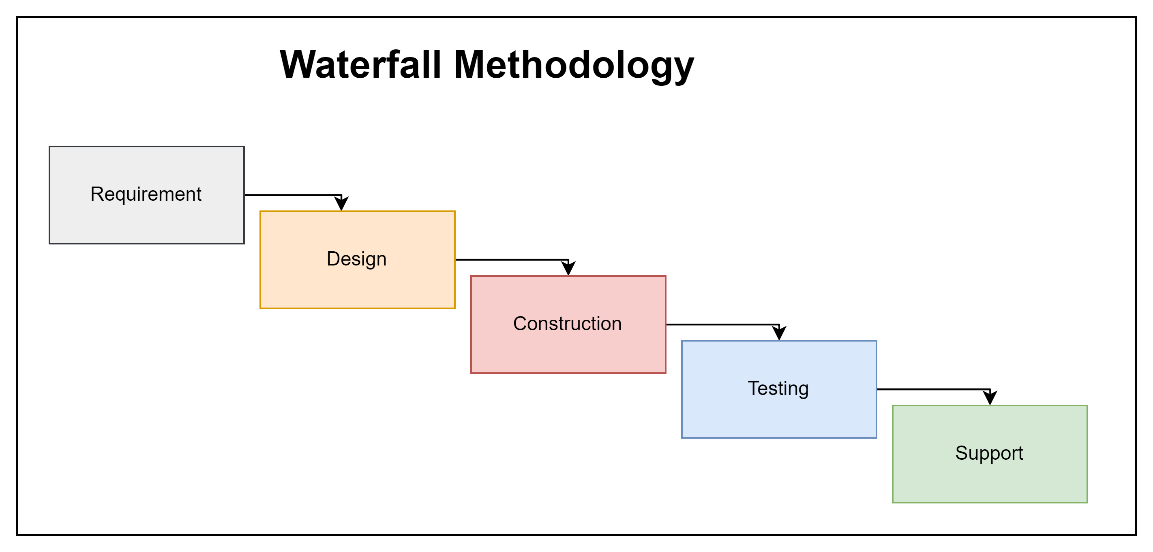
19: Waterfall Methodology

1. Registration Test Scenarios:
- Verify that a user can successfully register with valid information.
- Validate that the software prevents registration with incomplete or invalid data.
- Test the uniqueness of usernames to avoid duplicate registrations.
- Ensure that the registration process generates and stores ECC keys correctly.

2. Login Test Scenarios:
- Verify that a registered user can log in with correct credentials.
- Test the software's behavior when incorrect login credentials are provided.
- Validate that the login process securely authenticates users.

3. File Encryption Test Scenarios:
- Test the encryption of various file types (text, image, audio, video) and ensure their successful encryption.
- Validate that the encryption algorithm used provides the expected level of security.
- Verify that the encrypted files cannot be accessed without the corresponding decryption key.

4. File Decryption Test Scenarios:
- Test the decryption of encrypted files and validate that the original content is restored.
- Ensure that the correct decryption algorithm and key are used for each encrypted file.
- Validate that decryption fails or produces incorrect results when incorrect decryption keys are provided.

5. Text Hiding in Images Test Scenarios:
- Test the hiding of text within images and validate the concealment of the text.
- Verify that the hidden text can be successfully extracted from the images.
- Validate that the images appear unaltered after the text hiding process.

6. PDF Password Protection Test Scenarios:
- Test the password protection feature for PDF files and validate that passwords are correctly applied.
- Ensure that password-protected PDF files cannot be opened or accessed without the correct password.
- Verify that the software handles password-protected PDF files securely and accurately.

7. Database Management Test Cases:
- Test the functionality to store, retrieve, update, and delete user information and ECC keys from the database.
- Validate the accuracy and integrity of data stored in the CSV database.
- Test the backup and recovery mechanisms to ensure data can be restored in case of system failures.

8. GUI and User Experience Test Cases:
- Test the user interface (GUI) for responsiveness, ease of use, and intuitive navigation.
- Validate that error messages and notifications are displayed appropriately for user actions.
- Verify that the software provides clear instructions and guidance to users throughout the application.

By considering these test scenarios and test cases, the "SecureInfo" software undergoes comprehensive testing to ensure its functionality, security, and user experience. This rigorous testing approach helps identify and address any issues or vulnerabilities, ensuring a robust and reliable software application.

7.2 Performance Evaluation:
Performance evaluation is crucial to assess the efficiency and responsiveness of the "SecureInfo" software. The following points outline the key aspects of performance evaluation:
1. Execution Speed: Measure the time taken by the software to perform encryption, decryption, file hiding, and PDF password protection operations, ensuring they are performed within acceptable time limits.
2. Resource Utilization: Monitor the software's utilization of system resources such as CPU, memory, and disk space during various operations to ensure efficient resource management and avoid excessive resource consumption.
3. Scalability: Evaluate the software's ability to handle increasing data volumes and user concurrency without significant performance degradation, ensuring smooth operation under high workload conditions.
4. Responsiveness: Assess the software's responsiveness in terms of user interface interactions, such as user input processing, screen transitions, and response to user commands, ensuring a seamless and smooth user experience.
5. Error Handling: Evaluate the software's behavior in handling errors and exceptional scenarios, ensuring proper error messaging, graceful error recovery, and minimal disruption to the overall functionality.
Performance evaluation involves conducting tests, collecting performance metrics, and analyzing the results to identify any performance bottlenecks or areas for improvement. This assessment ensures that the "SecureInfo" software meets performance expectations and delivers a satisfactory user experience.

7.3 Security Assessment:
Security assessment is essential to evaluate the robustness of the "SecureInfo" software's security measures. The following points highlight key aspects of security assessment:
1. Vulnerability Testing: Identify potential vulnerabilities through penetration testing and vulnerability scanning to ensure that the software is resilient against attacks.
2. Encryption Strength: Assess the strength of the encryption algorithms used in the software to ensure they meet industry standards and provide effective protection for sensitive data.
3. User Authentication: Evaluate the effectiveness of the user authentication mechanism to prevent unauthorized access and verify the integrity of user credentials.
4. Data Protection: Verify that user data, including ECC keys, passwords, and other sensitive information, is appropriately stored, encrypted, and protected against unauthorized access.
Security assessment involves analyzing the software's security controls, performing security testing, and addressing any identified vulnerabilities or weaknesses to ensure the confidentiality, integrity, and availability of user data and operations.

- RESULTS AND DISCUSSION

The Results and Discussion section presents the findings and analysis of the "SecureInfo" software. The following points outline the key aspects of this section:

  - Functionality Evaluation: Evaluate the functionality of the software by testing various operations, including encryption and decryption of different file types, text hiding in images, and PDF password protection. Discuss the successful execution of these operations and any observed limitations or challenges.
  - User Experience: Gather feedback from users regarding their experience with the software. Discuss user satisfaction, ease of use, and any suggestions for improvement based on user feedback.
  - Performance Analysis: Present the performance metrics obtained during the performance evaluation phase. Discuss the execution speed, resource utilization, scalability, and responsiveness of the software. Compare the results with performance expectations and highlight any areas that require optimization.
  - Security Assessment Results: Discuss the findings of the security assessment, including vulnerability testing and encryption strength evaluation. Highlight any vulnerabilities identified, security measures implemented, and steps taken to address any security weaknesses.
  - Comparison with Objectives: Compare the achieved results with the initially defined objectives of the project. Evaluate whether the software successfully meets the objectives and discuss any deviations or areas where further improvements are required.
  - Limitations and Future Enhancements: Identify and discuss any limitations or constraints encountered during the development and testing phases. Propose potential enhancements or future directions for the software, addressing areas such as additional file formats, advanced encryption algorithms, or improved user interface.

The Results and Discussion section provides a comprehensive overview of the outcomes and analysis of the "SecureInfo" software, offering insights into its functionality, performance, security, and potential for future enhancements.

- CONCLUSION

The Conclusion section summarizes the key findings and outcomes of the "SecureInfo" software project. The following points highlight the main aspects to be covered in this section:

  - Achievement of Objectives: Reiterate the objectives of the project and discuss the extent to which they have been achieved. Emphasize how the software successfully addresses the need for secure information storage, encryption, and decryption across various file types.
  - Key Features and Contributions: Highlight the key features and functionalities of the software, such as ECC asymmetric encryption, text hiding in images, PDF password protection, and user-friendly GUI. Discuss how these features contribute to enhancing information security and user experience.
  - Benefits and Significance: Discuss the benefits and significance of the "SecureInfo" software in the context of information security. Explain how it provides users with a secure platform for storing, encrypting, and decrypting their sensitive data, protecting against unauthorized access and potential threats.
  - Evaluation and Validation: Summarize the evaluation and validation results, including functionality testing, performance analysis, and security assessment. Reinforce the reliability, efficiency, and effectiveness of the software based on the collected data and feedback.
  - Future Prospects: Explore potential future enhancements and advancements for the software. Discuss possible avenues for incorporating additional features, improving performance, and expanding compatibility with different platforms and file formats.

The Conclusion section serves as a final reflection on the "SecureInfo" software project, highlighting its achievements, contributions, and significance in ensuring information security. It also provides a platform for discussing future prospects and potential developments in line with evolving security needs and technological advancements.

- REFERENCES

The References section provides a list of sources that were consulted and utilized throughout the "SecureInfo" software project. The following points summarize the key references for this project:
  - Article on Types of Encryption: [Source: Prey Project] (https://preyproject.com/blog/types-of-encryption-symmetric-or-asymmetric-rsa-or-aes#:~:text=Symmetric%20encryption%20involves%20using%20a,specific%20needs%20of%20the%20user)
- This article provided valuable information on symmetric and asymmetric encryption, including RSA and AES algorithms, which helped in understanding the concepts and implementing them in the software.
  - YouTube Channels for Algorithm Learning:
[GateSmashers](https://www.youtube.com/@GateSmashers), [5MinutesEngineering](https://www.youtube.com/@5MinutesEngineering), [Rajeshwari Gundla](https://www.youtube.com/@rajeshwarigundla4038) - These YouTube channels offered informative tutorials and explanations on various algorithms, including ECC encryption and decryption, which assisted in developing the encryption and decryption functionalities of the software.
  - YouTube Channel for GUI Development:
[CodeWithHarry](https://www.youtube.com/@CodeWithHarry)
- This YouTube channel provided comprehensive tutorials on GUI development using the tkinter library in Python. It served as a valuable resource for implementing the user interface of the "SecureInfo" software.
  - Logo Creation: [Logo.com](https://logo.com/),
[Adobe Spark](https://www.adobe.com/express/create/logo)
- These platforms were used for creating the logo of the "SecureInfo" software. They offered user-friendly tools and templates for designing professional logos.
These references contributed to the theoretical understanding, algorithm implementation, GUI development, and logo creation aspects of the "SecureInfo" software project. They were instrumental in enhancing the knowledge and skills required to develop a secure and user-friendly software solution.

****

